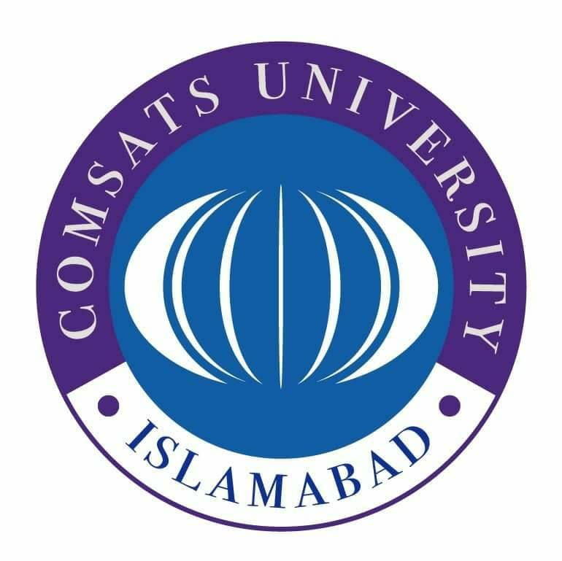

Ideology & Constitution of Pakistan
( Course Code: HUM113 )

Name: Muhammad Abdullah
Roll No # FA24-BSE-042
Instructor Name: Mam Nadia Khalid

Assignment - 1
The Lucknow Pact 1916: British Policies, Muslim League Strategy, and Jinnah’s Role
Introduction
The year 1916 is one such moment of optimism in the political history of the subcontinent. Much to the disappointment of the decades, long drift between Hindus and Muslims, the two finally sat down, and common political platform was agreed upon. This was the Lucknow Pact. It didn't happen overnight. This accord was preceded by years of frustration, planning and the initiatives of leaders who truly held the belief that unity was the solution. One of them stands out like a star Muhammad Ali Jinnah.
I will attempt to explain in this assignment how British policies led the Muslims into the path of Hindu-Muslim unity, how the Muslim league shifted its focus and how Jinnah became the mediator between two communities.
1. British Policies That Pushed Muslims Towards Unity
1.1 The Annulment of the Partition of Bengal (1911)
In 1905, the Muslims were relieved by the Partition of Bengal. They finally got a province which they dominated East Bengal. They were safe against the Hindu domination. The British government however reversed the partition in 1911. This was a huge blow.
According to the handouts, "The Bengali Muslims who had been benefiting as a result of the partition were aggrieved and disappointed." (Lecture 04, Page 11)
This was not a mere emotional anger. It was political. The Muslims knew that the British would not be able to take care of their interests indefinitely. When the British were able to reverse something that benefited Muslims at the expense of quieting the Hindu wrath, then the Muslims have to re-strategize.
1.2 Aggressive British International Policies
British policies in the Muslim world were also becoming a matter of concern around the same time. European powers, and among them Britain, attacked the Ottoman Empire whose Caliph was regarded to be the Caliph of Islam. The Indian Muslims were experiencing a trampling of their religious feelings. This brought the impression that Hindus and Muslims must unite against a shared oppressor.
1.3 The Minto-Morley Reforms (1909) and Hindu Reaction
The Indian Councils Act 1909 gave Muslims separate electorates. For Muslims, it was a victory. But Hindus opposed it bitterly. The Congress launched campaigns against this provision. This made Muslims realize that Hindus still did not accept them as a separate nation. But at the same time, it also opened a door, if Hindus were willing to negotiate, maybe Muslims could secure more rights through dialogue.
2. Shift in Muslim League Strategy
2.1 From Loyalty to Self-Government
Before 1912, the Muslim League was all about loyalty to the British. They believed that by staying loyal, they could protect Muslim interests. But the annulment of Bengal's partition shattered that belief.
The handouts clearly mention: "In December 1912, the Muslim league changed its aim from loyalty to form self-government suitable to India." (Lecture 04, Page 15)
This was a huge shift. Now, instead of relying on the British, the League wanted to work with other Indian communities to demand self-rule. This opened the door for talks with the Congress.
2.2 The League Retains Its Muslim Identity
Even though the League moved towards cooperation with Hindus, it did not give up its core identity. The handouts note that "the League retained the right to modify self-rule by their needs and requirements." (Lecture 04, Page 15)
This was important. Muslims were not simply merging with the Congress. They were willing to work together, but on terms that protected their community's interests.
2.3 Joint Sessions and Committee Formation
In 1915, both the Muslim League and the Congress held their annual meetings in Bombay. This was not a coincidence. It was a planned effort to bring the two parties closer. After these meetings, a committee was formed to work out a common scheme of reforms.
According to the handouts: "The committee prepared a scheme in November 1916. The plan was approved by both the parties in December 1916 at the respective sessions at Lucknow." (Lecture 04, Page 15)

3. Jinnah's Role in Fostering Hindu-Muslim Unity
3.1 Jinnah – The Ambassador of Hindu-Muslim Unity
If there was one man who made the Lucknow Pact possible, it was Muhammad Ali Jinnah. At that time, Jinnah was not seen as a Muslim leader alone. He was a member of both the Congress and the Muslim League.
The handouts describe him as "a man free of any religious prejudice, as well as a brilliant advocate and debater." (Lecture 04, Page 15)
This is a side of Jinnah that many people forget today. He genuinely believed that Hindus and Muslims could live together and work together for a free India. He was not communal. He was practical.
3.2 His Presidential Speech at Lucknow
When Jinnah spoke at the Lucknow session, his words reflected his deep commitment to unity:
"India's real progress can only be achieved by a true understanding and harmonious relations between the two great communities. About our affairs, we can depend upon nobody but ourselves." (Lecture 04, Page 15)
Look at the emotion in these words. He was telling both communities: stop looking at the British. Stop fighting each other. Sit together and decide your own future. This was the message of a statesman, not just a politician.
3.3 Building Trust Between Communities
Jinnah's greatest contribution was building trust. The Congress agreed to separate electorates for Muslims – something they had always opposed. Why? Because they trusted Jinnah. They knew he was not asking for anything unreasonable. Muslims on the other hand accepted to sacrifice their majority in Bengal and Punjab, a big sacrifice. Why? They did so because they had faith in Jinnah that he had made them the best possible offer.
The handouts mention: "The Muslims had to pay a big price of losing the majority in Bengal and Punjab to obtain some concessions." (Lecture 04, Page 16)
This was a give-and-take. And Jinnah was the man who made both sides feel comfortable with the exchange.
4. Key Features of the Lucknow Pact
In order to comprehend the pact completely, the following are its key points:
- Separate Electorates Congress accepted separate electorates among Muslims. This was a great victory to the Muslim identity.
- Representation One-Third Muslims would occupy one-third of the Imperial Legislative Council.
- Weightage Formula: In provinces where the Muslims were in majority (such as Punjab and Bengal), they would receive a bit less than what their population was. They would receive more than the minority provinces of the population. This balanced things out.
- Provincial Autonomy: Provinces must be given as much freedom as possible in the administration and finances.
- Cartel Veto: The members of a certain community would have to pass a 75 percent majority to enact any resolution impacting that community. This safeguarded the minority interests.
- Demand of Self-Government: The two parties collaborated in their demand of self-rule in India.
5. Significance of the Lucknow Pact
5.1 Hindu Muslim Unity
The handouts call it "an excellent example of Hindu Muslim unity" and note that "It was the first and last pact signed between the Congress and the Muslim league." (Lecture 04, Page 15)
Sadly, this unity did not last. But for a brief moment, it showed that Hindus and Muslims could agree on a political future together.
5.2 Congress Accepted Muslim Identity
For the first time, the Congress officially accepted that Muslims were not just a religious minority but a political community with special needs. This was a big step.
5.3 Blueprint for Future Reforms
The Lucknow Pact's scheme of representation was later used in the Montague-Chelmsford Reforms of 1919. So, it was not just a symbolic agreement. It actually shaped future constitutional developments.
5.4 Jinnah's Rise as a National Leader
The pact established Jinnah as a leader who could talk to both sides. Even though later events took a different turn, at this moment, Jinnah was the hope of a united India.
Conclusion
Lucknow Pact was a political agreement. It was a maturity period in the struggle of freedom in India. The British policies particularly the annulment of partition of Bengal made the Muslims learn that they could not count on the colonial masters indefinitely. The Muslim League made a smart decision to switch their policy to the one of allegiance to self-rule. In the middle of it all was Jinnah who thought of unity, worked towards unity and briefly succeeded in his task.
As we read about the Lucknow Pact to-day we are moved to mixed emotions. Pride in the fact that our leaders were able to transcend differences. And that sadness that the unity was not to be. But history is what it is. Our job is to learn from it.
References
- HUM113 Ideology and Constitution of Pakistan, Lecture 04 Handouts, COMSATS University Islamabad, Virtual Campus.
- HUM113 Ideology and Constitution of Pakistan, Lecture 03 Handouts, COMSATS University Islamabad, Virtual Campus.

